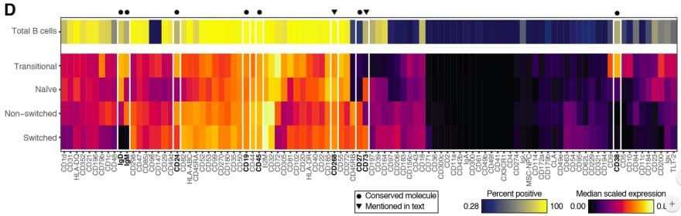Astrolabe Diagnostics is a fully bootstrapped five-person biotech startup. We offer the Antibody Staining Data Set (ASDS), a free service that helps immunologists find out the expression of different molecules (markers) across subsets in the immune system. Essentially, the ASDS is a big table of numbers, where every row is a subset and every column a marker. Recently, the Sean Bendall lab at Stanford released the preprint of a similar study, where they measured markers for four of the subsets that the ASDS covered. Since the two studies used different techniques for their measurements I was curious to examine the correlation between the results. However, the preprint did not include any of the actual data. The closest was Figure 1D, a heat map for 98 of the markers measured in the study:

I decided to take the heat map image and “reverse engineer” it into the underlying values. Specifically, what I needed was the “Median scaled expression” referred to in the legend in the bottom right. Since I could not find any existing packages or use cases for easily doing this I decided to hack a solution.

First, I manually entered the marker names from the X-axis into a spreadsheet. Then, I cropped the above image, removing the legends, axes, and the top heat map row which includes an aggregate statistic not relevant to this exercise.

I loaded the image into R using the readPNG function from the png package. This results in a three-dimensional matrix where the first two dimensions are the X- and Y-values and the third is the RGB values. The X axis maps to the markers and the Y axis maps to the four subsets (“Transitional”, “Naive”, “Non-switched”, and “Switched”), and I wanted to get a single pixel value for each (Subset, Marker) combination.

Deciding on the row for each subset was easy enough: I loaded the image in GIMP and picked rows 50, 160, 270, and 380. In order to find the column for each marker I initially planned to iterate over the tile width. Unfortunately, tile widths are not consistent, which is further complicated by the vertical white lines. I ended up choosing them manually in GIMP as well:

Marker,Pixel CD1d,14 CD31,40

HLA-DQ,70 CD352,100 CD21,128 CD196,156 CD79b,185 CD1c,219

...

I could now get the RGB value for a (Subset, Marker) from the PNG. For example, if I wanted the CD31 value for the “Non-switched” subset, I would go to *heat_map_png[270, 40, ]*. This will give me the vector *[0.6823529, 0.0000000, 0.3882353]*. In order to map these values into the “Median scaled expression” values, I used the legend in the bottom left. First, I cropped it into its own PNG file:

I imported it into R using *readPNG*, arbitrarily took the pixels from row 10, and mapped them into values using *seq*:

# Import legend PNG, keep only one row, and convert to values. The values "0" # and "0.86" are taken from the image.

legend_png <- png::readPNG("legend.png") legend_mtx <- legend_png[10, , ]

legend_vals <- seq(0, 0.86, length.out = nrow(legend_mtx))

At this point I planned to reshape the heat map PNG matrix into a data frame and join the RGB values into the legend values. However, this led to two issues.

One, reshaping a three-dimensional matrix into two dimensions is a headache since I want to make sure I end up with the row and column order

I need. Sticking to the spirit of the hack, I iterated over all (Subset, Marker) values instead. This is inelegant (iterating in R is frowned upon) but is a reasonable compromise given the small image size.

Two, I can’t actually join on the legend RGB values. The heat map uses a gradient and therefore some of its values might be missing from the legend itself (the reader can visually infer them). Instead, I calculated the distance between each heat map pixel and the legend pixels and picked the nearest legend pixel for its “Median scaled expression”.

heat_map_df <- lapply(names(marker_cols), function(marker) { lapply(names(cell_subset_rows), function(cell_subset) {

v <- t(heat_map_png[cell_subset_rows[cell_subset], marker_cols[marker], ]) dists <- apply(legend_mtx, 1, function(x) sqrt(sum((x - v) ^ 2)) data.frame(

Marker = marker CellSubset = cell_subset

Median = legend_vals[which.min(dists)] stringsAsFactors = FALSE

}) %>% dplyr::bind_rows(

}) %>% dplyr::bind_rows()

I now have the heat_map_df values I need to compare to the ASDS! As a sanity check, I reproduced the original heat map using ggplot:

heat_map_df$Marker <-

factor(heat_map_df$Marker, levels = names(marker_cols) heat_map_df$CellSubset <-

factor(heat_map_df$CellSubset, levels = rev(names(cell_subset_rows)))

ggplot(heat_map_df, aes(x = Marker, y = CellSubset)) + geom_tile(aes(fill = Median), color = "white") + scale_fill_gradient2(

name = "Median Scaled Expression"

low = "black", mid = "red", high = "yellow" midpoint = 0.4) +

theme(axis.text.x = element_text(angle = -90, hjust = 0, vjust = 0.4), axis.title = element_blank()

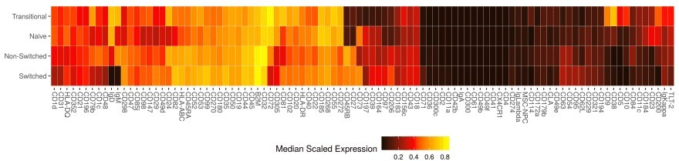legend.position = "bottom" panel.background = element_blank()

The resulting code gets the job done and can be easily repurposed for other heat maps. There will be some manual work involved, namely, setting *cell_subset_rows* to the rows in the new heat map, updating *marker_cols.csv* accordingly, and setting the boundary values in the *seq* call when calculating *legend_vals*. Furthermore, we should be able to adapt the above into a more autonomous solution by calculating the boundaries between tiles using *diff*, running it separately on the rows and the columns (getting the row and column labels will not be trivial and will require OCR). For a one-time exercise, though, the above hack works remarkably well — sometimes that is all the data science you need to get the job done. …